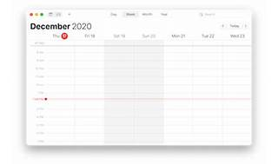

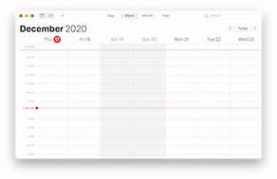

Explore

**AppKit** is an **Apple framework** that provides the necessary tools and components for building the user interface of macOS applications. [It handles everything from drawing windows and buttons to managing events and interactions with the operating system1](https://developer.apple.com/documentation/appkit).

Here are **five free reference links** where you can learn more about **AppKit**:

1. [**Apple Developer Documentation**](https://developer.apple.com/documentation/appkit): Explore official documentation from Apple, covering essential concepts, views, controls, and more[1](https://developer.apple.com/documentation/appkit).
2. [**macOS Apprentice: Using AppKit in SwiftUI**](https://www.kodeco.com/books/macos-apprentice/v1.0/chapters/17-using-appkit-in-swiftui): Learn how to integrate AppKit into SwiftUI apps to enhance functionality and structure your applications effectively[2](https://www.kodeco.com/books/macos-apprentice/v1.0/chapters/17-using-appkit-in-swiftui).
3. [**WWDC21 Video: What’s New in AppKit**](https://developer.apple.com/videos/play/wwdc2021/10054/): Discover the latest advancements in Mac app development, including control features, SF Symbols 3, TextKit 2, and Swift features[3](https://developer.apple.com/videos/play/wwdc2021/10054/).

Feel free to explore these resources to deepen your understanding of AppKit! 🖥️🍎